Pilot
Chocolate pellets vs chow pellets with increased “work” protocol
5 mice do each task
Large acrylic box
2 Feds (1 with grain pellets 1 with choco)
10 long sippers
Weigh mice between tasks!

Pre-Training (set up on Friday)
- 2-3 nights of training in acrylic boxes with 2 FEDS on FR1. One FED with chocolate, the other with chow. (could be a weekend – with chow in the cage, and 2 sipper tubes: https://github.com/KravitzLab/KreedLabWiki/wiki/Long-Sipper).
- This also helps them acclimate to the acrylic boxes as their home.
- Ideally by Monday they have sampled a lot of both FEDs - >100 of each?

Testing (M-F)
- Pull chow on Monday
- FR1 on both – 48 hours (Tu, Wed). Prediction:
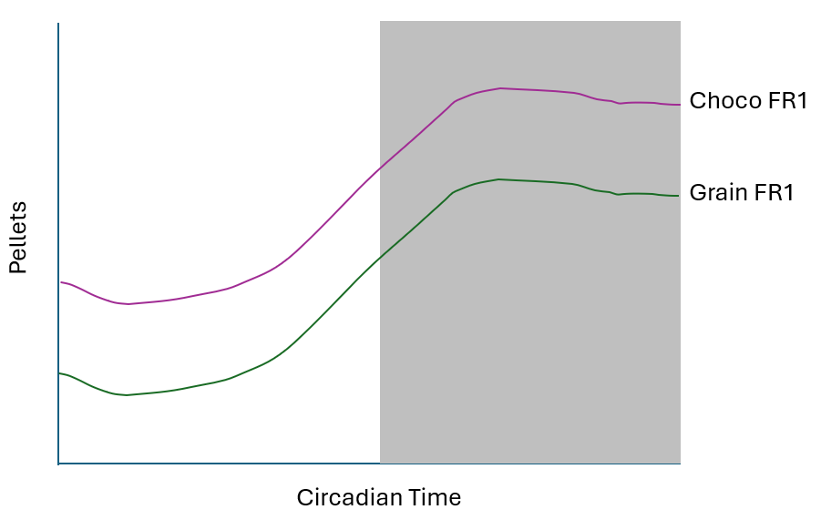
We use this to understand baseline preference at the same cost (mice like chocolate)

- Move chocolate to FR5, leave grain on FR1 for 4 days (Thurs-Sun ). Prediction:
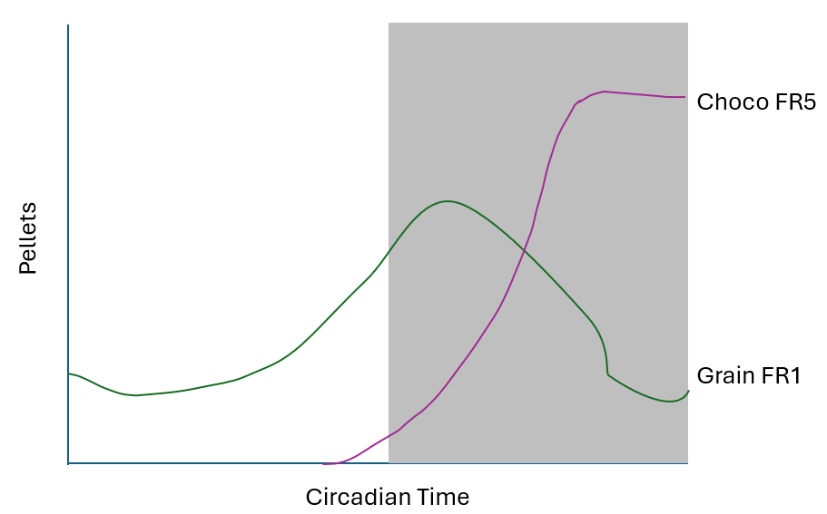
We use this to see if they still like chocolate if it costs more. Also see if this evolves over 4 days.

- 5th day - Sunday night no food overnight
- Monday morning – FEDs (FR1 chow, FR5 chocolate) back in until Monday
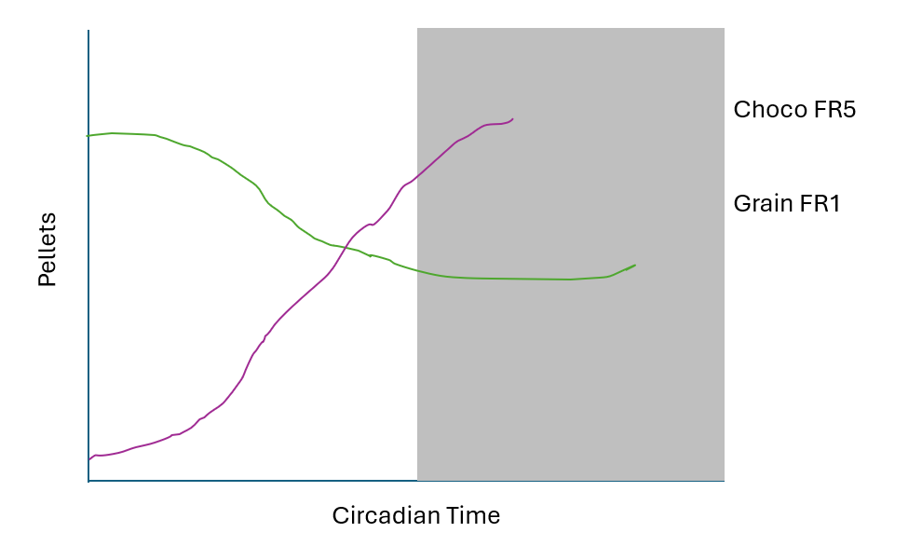
Does this shift them back to FR1 chow acutely because they’re hungry?

Future ideas:
- Short term experiments (below)
- Can this predict HFD-induced weight gain?

Sated experiments
Day 1) 10 -11am 1 hour with chow and choco at FR1
Day 2) 10- 11am 1 hour with chow at FR1 and Choco FR5

Fasted
Day 3) 10 -11am 1 hour with chow and choco at FR1
Day 4?) 10- 11am 1 hour with chow at FR1 and Choco FR5

